Week 2: SOC Alert Management, Incident Response, and Threat Analysis

Meet Tank
Soc Week-2
Task 1

1)Alert Priority Levels
In a Security Operations Center (SOC), many security tools such as SIEM, EDR, firewalls, and IDS generate alerts every day. These alerts can range from harmless system messages to serious cyberattacks.
Because SOC analysts cannot investigate every alert at the same time, alert priority levels are used to decide which alerts must be handled first.
Alert prioritization ensures that Critical threats are addressed immediately,Business operations are protected,Soc resources are used efficiently,False positives and low-risk alerts do not waste time.
SOC environment, alerts are usually classified into four priority levels:
- Critical
- High
- Medium
- Low

CVSS System
In a SOC, not all alerts are equal, so we use a system to decide which ones need attention first. Alert priority is based on how much damage an attack could do and how fast it is spreading. We often use the CVSS (Common Vulnerability Scoring System) to give each alert a number from 0 to 10; for example, a score of 9.8 would be critical and needs to be fixed immediately, while a 4.0 might be medium and can wait a bit. Incident classification helps us label the type of attack we are seeing, like phishing, malware, or a DDoS attack. By using standard labels from the MITRE ATT&CK framework, every analyst on the team understands exactly what the hacker is trying to do, which makes the investigation much faster.ALERT CLASSIFICATION (GOOGLE SHEETS)
This is SOC documentation work, done from VM1 browser.

When a real threat is confirmed, we follow a specific game plan called the incident response lifecycle, which is usually based on the NIST SP 800-61 guide. It consists of six main steps to ensure nothing is missed during the chaos of an attack: • Preparation: Setting up tools like Wazuh and creating playbooks before an attack happens. • Identification: Triage and analysis to confirm if an alert is a true positive or just a false alarm. • Containment: Stopping the threat from spreading, such as isolating an infected VM from the rest of the network. • Eradication: Completely removing the cause of the incident, like deleting malware or closing a backdoored account. • Recovery: Getting the systems back to normal and monitoring them to make sure the attacker doesn't return. • Lessons Learned: A post-mortem meeting to discuss what went well and how to improve our defenses for next time

A key part of being an analyst is making sure that any data you collect can be used as proof later. This is called evidence preservation. When we find a compromised system, we use tools like Velociraptor or FTK Imager to grab volatile data, which is information that disappears when a computer is turned off, like running processes or network connections. To make sure the evidence is never changed or faked, we create a SHA256 hash, which is a unique digital fingerprint for the file. If even one tiny bit of the file changes, the hash will change, proving that the evidence has been tampered with.

SOC Lab Environment The practical tasks for this week were done using a lab setup with two virtual machines to simulate a real security operations center. The first machine is the manager, which runs the Wazuh dashboard and is responsible for collecting all the logs and showing alerts when something suspicious happens. The second machine is the agent, This machine acts as the endpoint that is being watched. This setup is important because it shows how a real SOC works, where many different computers all send their security data to one central monitoring system. By using these two machines, I was able to generate a real attack on the agent and then see exactly how the manager detected it and created an alert.

2) Incident Classification
Incident classification is the process of identifying and categorizing security incidents based on their nature and impact. Common incident categories include malware, phishing, DDoS, insider threats, and data exfiltration. SOC analysts use standardized frameworks such as MITRE ATT&CK, ENISA Incident Taxonomy, and VERIS to label incidents consistently.
Additionally, incidents are enriched with contextual metadata like affected systems, timestamps, source IPs, and indicators of compromise (IOCs). Proper classification and enrichment help streamline investigations, improve response accuracy, and enhance SOC efficiency. Standardized frameworks are used to ensure uniform classification across organizations. The MITRE ATT&CK framework maps incidents to attacker tactics and techniques, such as T1566 for phishing, providing insight into adversary behavior. Other taxonomies like ENISA and VERIS offer structured approaches for recording and sharing incident information. In addition to classification, incidents are enriched with contextual metadata such as affected systems, timestamps, source IP addresses.
Incident Categories
1. Malware Incident :- Malicious software detected.
2. Phishing Incident:- Fake emails or messages to steal credentials.
3. DDoS Incident:- Flooding a server with traffic to make it unavailable.
4. Insider Threat:- Attack or misuse by an employee.
5. Data Exfiltration:- Sensitive data stolen and sent outside.

Standard Taxonomy Frameworks
1.Mitra Attack:- Describes how attackers perform attacks.
2. Enisa Incident Taxonomy:- Classifies incidents at organizational and national level.
3. Veris Framework:- Standard vocabulary for incidents.

Contextual Metadata (Incident Enrichment)
Metadata = Extra details that make investigation easier.

Common Metadata Used in SOC:
Metadata | Example
Affected system | Employee laptop
Timestamp | 07-Jan-2026 10:30 AM
Source IP | 192.168.1.10
Destination IP | 45.33.22.10
IOC | Malicious hash
User | employee@company.com

Incident Ticket – SSH Brute Force Attempt
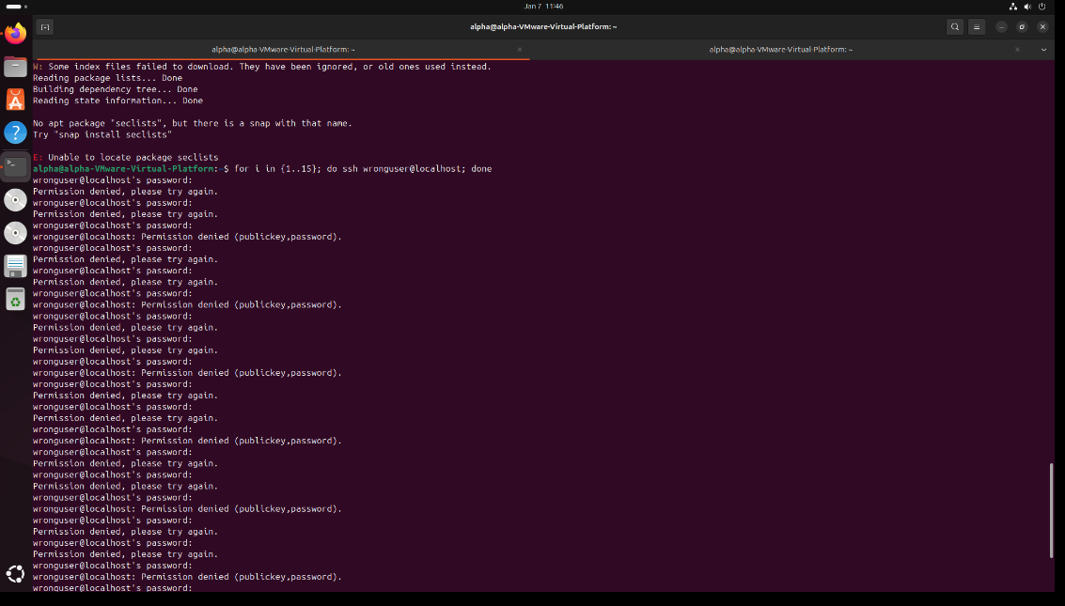
3) Basic Incident Response
Incident Response (IR) is a structured approach used by cybersecurity teams to detect, analyze, contain, and recover from security incidents such as malware infections, unauthorized access, data breaches, and denial-of-service attacks. The primary goal of incident response is to minimize damage, reduce recovery time, and ensure business continuity while preserving evidence for investigation and compliance purposes. A well-defined incident response process is critical for organizations to effectively manage security threats in a timely and controlled manner.

Incident Response Lifecycle
The incident response lifecycle provides a systematic framework for handling security incidents. This lifecycle is defined in standards such as NIST SP 800-61 and is widely followed by Security Operations Centers (SOCs).

1. Preparation
Preparation involves establishing policies, procedures, tools, and resources before an incident occurs. This phase ensures that the organization is ready to respond effectively to security incidents.
Key activities include:
- Developing incident response policies and playbooks
- Defining roles and responsibilities of the incident response team
- Deploying security tools such as SIEM, EDR, and SOAR platform

2. Identification
Identification is the phase where a potential security incident is detected and analyzed to determine whether it is a true incident or a false positive.
Key activities include:
- Monitoring alerts from SIEM, IDS/IPS, EDR, and security tools
- Performing alert triage and initial analysis
- Correlating events to identify attack patterns
- Classifying incidents based on severity and impact
Accurate identification is crucial to avoid unnecessary actions and to prioritize high-risk incidents.

3. Containment
Containment focuses on limiting the spread and impact of the incident. The objective is to prevent further damage while maintaining evidence integrity.
Key activities include:
- Isolating affected systems from the network
- Blocking malicious IP addresses or user accounts
- Disabling compromised credentials
- Applying temporary fixes or segmentation controls
Containment strategies are often divided into short-term containment (immediate actions) and long-term containment (temporary solutions until eradication).

4. Eradication
Eradication involves removing the root cause of the incident and eliminating all malicious components from the environment.
Key activities include:
- Removing malware, backdoors, or malicious files
- Patching vulnerabilities exploited during the attack
- Updating security configurations and access controls
- Ensuring that threat actors no longer have access
This phase ensures that the threat is completely eliminated before recovery begins.

5. Recovery
Recovery focuses on restoring affected systems and services to normal operation in a secure manner.
Key activities include:
- Restoring systems from clean backups
- Monitoring systems for signs of reinfection
- Validating system integrity and functionality
- Gradually reconnecting systems to the production network

6. Lessons Learned
The lessons learned phase is conducted after the incident is fully resolved. It aims to improve future incident response capabilities.
Key activities include:
- Conducting post-incident reviews and root cause analysis
- Documenting timelines, actions taken, and outcomes
- Identifying gaps in controls, tools, or procedures
- Updating incident response plans and playbooks
- Implementing security improvements and preventive measures
This phase strengthens the organization’s security posture and helps prevent similar incidents in the future.

Incident Description
Multiple failed SSH authentication attempts were detected on the endpoint system (VM2). The Wazuh agent identified repeated password failures through the SSH daemon, indicating a potential brute-force attack targeting the SSH service. The event was generated from system logs monitored via journald and decoded by the SSHD decoder.

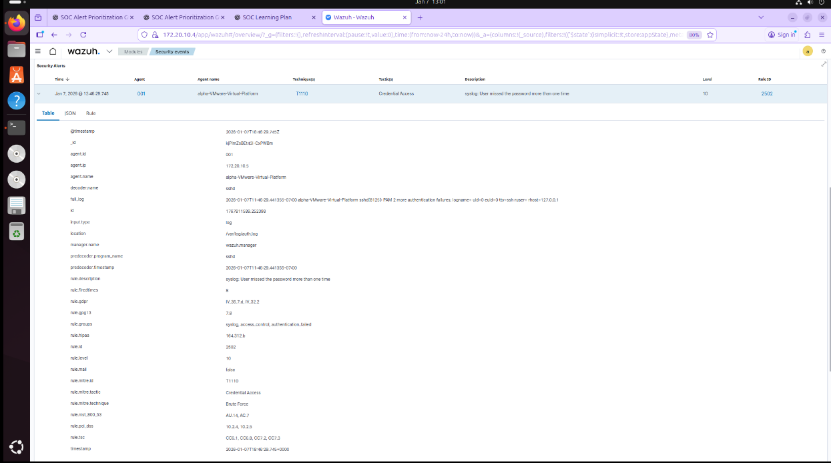
Threat Intelligence Validation – VirusTotal
In this step, the source IP address detected in the Wazuh SSH brute-force alert was analyzed using VirusTotal to determine whether the activity was malicious or a false positive. VirusTotal aggregates threat intelligence from multiple antivirus engines, security vendors, and community feeds.

The IP address was searched in VirusTotal, and the analysis results were reviewed for malicious detections, abuse reports, and historical behavior. The scan results helped confirm whether the IP was associated with known brute-force attacks, botnet activity, or suspicious behavior.This validation step allowed the SOC analyst to make an informed decision on alert severity and response actions. If the IP had been flagged as malicious, immediate containment and blocking would be required. If not, the alert could be classified as low risk or a potential false positive.

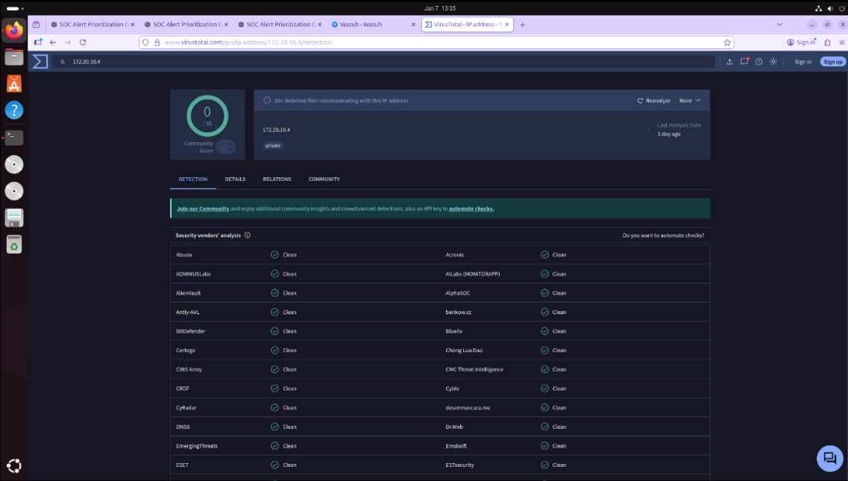

Incident Ticket Creation Detected security alerts were formally documented by creating incident tickets to ensure structured tracking and management of security incidents. Each incident ticket captured essential information, including the incident title, severity level, affected systems, identified indicators of compromise, and an initial analytical assessment. This structured documentation enables consistent incident handling, supports effective escalation to higher SOC tiers, and facilitates coordination among security teams. Additionally, maintaining detailed incident tickets ensures traceability and accountability throughout the entire incident lifecycle.

Alert Generation and Detection

The process starts when the agent machine generates logs based on activities happening on the system, such as a user trying to log in via SSH. These logs are sent to the Wazuh manager, which compares the raw data against a set of predefined security rules. For this task, the manager detected a series of failed login attempts that matched rule ID 2502, which is specifically for users missing their password more than once. Once a rule is triggered, the system generates a formal alert in the dashboard. This alert includes important technical details like the rule level, which was set to 10 for high severity, and the MITRE ATT&CK ID T1110 to show it was a brute force attempt. This automation is what allows a SOC to detect attacks in real-time instead of manually searching through thousands of log files.

Evidence Preservation and Chain of Custody

After completing the response, the final part of the process involves making sure that all information gathered is kept safe and documented correctly. This is known as evidence preservation and chain of custody, which is essential if the incident ever needs to be reviewed or used for a legal case. During the lab, I practiced these steps to ensure the data was handled properly: • Identifying evidence: I picked out the important logs and alert details from the ssh attack to save for the report. • Data collection: I used tools to gather the system information while it was still running to make sure no data was lost. • Hashing: I learned that every piece of evidence should have a unique digital fingerprint, or hash, to prove that it hasn't been changed since it was collected. • Documentation: I recorded who collected the data, when it was taken, and what tools were used, which creates a clear chain of custody. By following these rules, the SOC ensures that the investigation is reliable and that the evidence can be trusted by anyone who reviews the case later.

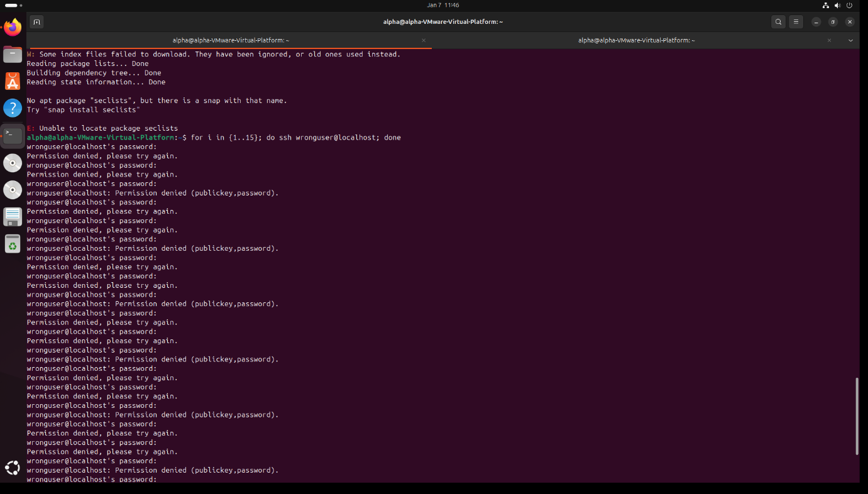

Conclusion

This week’s assignment provided a comprehensive understanding of both the theoretical and practical aspects of Security Operations Center (SOC) operations. Through structured learning and hands-on activities, key concepts such as alert prioritization, incident classification, alert triage, incident response, and evidence preservation were studied and applied in a simulated SOC environment.

